GEOG 678 – Week 2 Labs
Web App
- Short URL: https://arcg.is/mH0WD2
- Directly to map: https://tamu.maps.arcgis.com/apps/instant/basic/index.html?appid=0d8905eb55bf4f888c06b399ca476894
Screenshot from Field Maps.
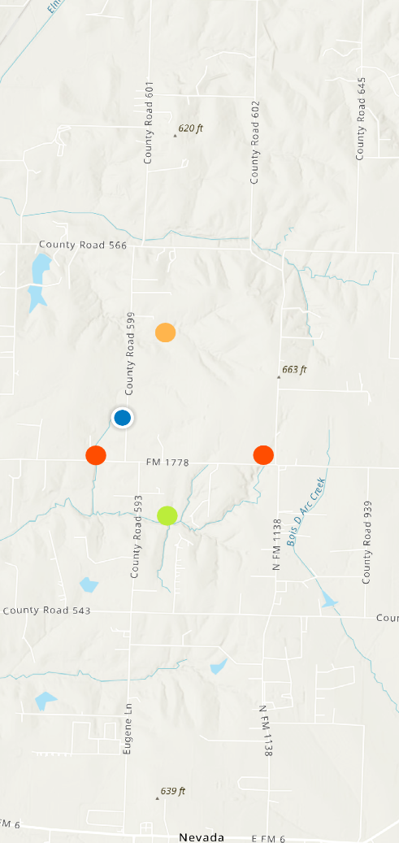
FYI, I don’t like the way it turned out. I would have preferred to build it in Field Maps Designer, but maybe we’ll do that later.

